

# DPS – MIS, DOHA- QATAR

# SUMMATIVE ASSESSMENT - I (2012–13)

# CLASS: VII

**Subject: General science Date: 27-09-2012**

Time allowed: 3 hours. Maximum Marks: 90

General instructions:

1. All questions are compulsory.
2. Marks are indicated against each question.
3. Please check that this question paper contains **7** printed pages only.
4. Please check that this question paper contains **33** questions.

**SECTION A (Physics)**

Q.1-Define atmospheric pressure. 1

Q.2-What is a tornado? 1

Q.3- a) Name any two types of thermometers. 2

b) Name the device used to measure wind speed.

c) What is a Beaufort scale?

Q.4- Give two differences between conduction and radiation. 2

Q.5- Convert 3020F into Celsius scale. 2

Q.6- Give reasons: 2

a) Many houses in India have ventilators.

b) Radiators of cars are painted black.

Q.7- Explain the phenomenon of sea breeze with a neat labelled

diagram. 3

Q.8- List any three safety precautions to be taken in cyclone prone areas. 3

Q.9- Why do we use mercury as a thermometric liquid?

(any **three** points) 3

Q.10-(a) Look at the diagram given below carefully. Why does the paper bag

move up?

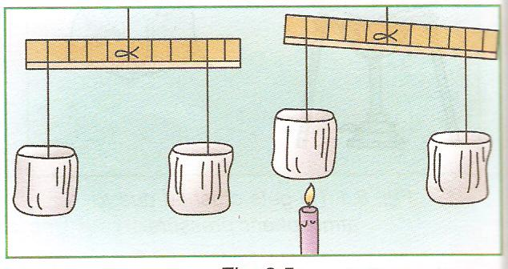

(b)‘A good absorber is a good radiator too’. Describe an activity that justifies this statement and support your answer with a neat, labelled diagram.

(2+3=5)

**Q.11-The following questions (Q11. to Q16) are Multiple Choice Questions (MCQ). Each question is a one mark question. You are to choose one most appropriate response out of the four provided to you. (1x6)**

i) Which mode of heat transfer cannot take place in solids?

(a) Radiation

(b) Convection

(c) Conduction

(d) None of the above

ii) A substance which conducts heat easily is called a/an

(a) good conductor

(b) bad conductor

(c) insulator

(d) None of the above

iii) Centre of cyclone is called the _______ of the cyclone.

(a) ear

(b) eye

(c) tornado

(d) funnel

iv) A cyclone churns up the sea and causes giant waves of water

known as

(a) stormy waves

(b) cyclone rush

(c) storm surges

(d) none of the above

v) Grass and mud are

1. used to build rural houses
2. bad conductors of heat
3. keep houses warm in winter and cool in summer
4. all of the above

vi) 320F corresponds to

(a) 00C

(b)1000C

(c) 2120C

(d) none of these

**SECTION B (Chemistry)**

Q.1- What is known as caustic soda? 1

Q.2- What is shearing? 1

Q.3- a.Why do we do scouring while processing wool?

b. Name two major wool producing countries in the world. 2

Q.4- Name four factors on which the climate of a place depends. 2

Q.5-a. Explain what happens when an acid reacts with a base.

b.Write a chemical equation to explain the above reaction. 2

Q.6- Differentiate between weather and climate? 2

Q.7-a. Write any two requirements of a good sheep shelter.

b. How will you test the purity of silk.

c. What does the wool mark logo indicate? 3

Q.8-a. Write two general properties of bases.

b. What are neutral substances? Give one example.

c. Write any two uses of sulphuric acid? 3

Q.9-a. What is global warming?

b. Write any two human activities that causes global warming.

c. Name two green house gases. 3

Q.10- a. Slaked lime is added to factory waste – why?

b. Write the chemical formula for the following.

i. Nitric acid

ii. Ammonium hydroxide.

c. What are indicators? Give one example. 5

Q.11- Answer the following **multiple choice questions**. Only one option

is the correct answer. (1x6=6)

(i) The colour of phenolphthalein turns pink in

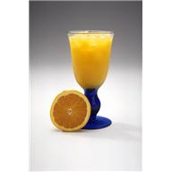  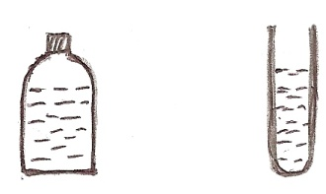  
 (a) Apple juice (b) Yogurt (c) vinegar (d) slaked lime solution

(ii) The common name for acetic acid is.

 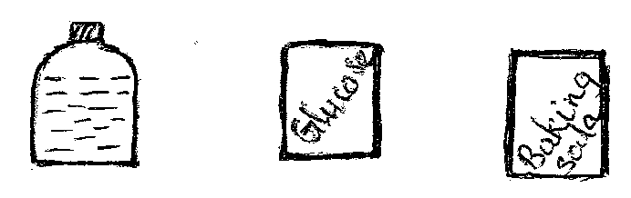

(a) curd (b) vinegar (c) glucose (d) baking soda

(iii) Silkworms are fed on

1. Strawberries (b) Berries (c) Mulberry leaves (d) Cabbage

(iv) Name that bird that migrates during winter.

1. Mynah (b) Crow (c) Siberian crane (d) Parrot

(v) The acid present in aerated drinks is

(a)acetic acid (b) tartaric acid (c) oxalic acid (d) carbonic acid

(vi) Which of the following indicator produce red colour when added to a   
 base?

(a) turmeric (b) china rose (c) phenolphthalein (d) litmus paper

**SECTION C (Biology)**

Q.1-Name the following: 1

(i) The compound formed when the red colour pigment in the blood combines with oxygen.

(ii) The type of respiration where glucose is incompletely oxidized

releasing less energy.

Q.2-Manures and fertilizers are added to the fields. Why? 1

Q.3-(i) Give **two** differences between a saprophyte and a green plant.

(ii) Why Drosera has taken up insectivorous mode of nutrition? 2

Q.4- (i) State **two** differences between respiration and combustion.

(ii) Name the body part involved in respiration in the following animals

(a)earthworm (b)cockroach 2

Q.5-What is the role of hydrochloric acid in the human stomach? 2

Q.6-Look at the diagram and answer the questions following it. 2



1. What is this experiment showing?
2. What is the function of caustic potash in this experiment?
3. Which chemical is used during starch test?

Q.7-(i) What causes opening and closing of stomata? 3

(ii) Why farmers plough or till the soil particles?

Q.8-Mr. Raj is 35 years old. His son is 4 years old. State **three** points

of difference in the structures of their teeth. 3

Q.9-Give reasons. 3

1. A hot shower removes the pain caused in the muscles after a strenuous physical activity like heavy weightlifting, running, cycling, etc.
2. People suffering from diarrhoea should drink plenty of

liquids, preferably containing some sugar and salts.

Q.10-Observe the diagram of human digestive system given, and answer the questions following it. 5

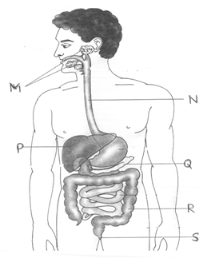

1. Label the parts-(M), (N), (P), (Q), (R), (S).
2. What is the basic difference in the digestion process of an Amoeba and human beings?
3. In which part of the small intestine does absorption of food occur?
4. Which structures in the small intestine are involved in absorption?

Q.11- Answer the following **multiple choice questions**. Only one option is the correct answer. (1x6=6)

1. The opening of pharynx into the larynx is guarded by
2. epidermis (b) epiglottis (c)epiblema (d) epithelium
3. The enzyme that converts starch to maltose in the small intestine

(a) Pancreatic amylase (b) Maltase (c) Salivary amylase (d) Sucrase

(iii) The food prepared by the leaves of green plants are stored as

(a) carbohydrates (b) fats (c) proteins (d) all

(iv) Exchange of gases takes place in woody stems through

1. stomata (b)lenticels (c)spiracles (d) all

(v) Which of the following is an autotroph?

(a) all animals (b) green plants (c) non-green plants (d) all plants

(vi) Tidal volume means

(a) oxygen moving from alveoli to blood

(b) amount of air breathed in or out in one go during normal respiration

(c) taking in of oxygen and giving out of carbon dioxide

(d) respiration taking place through cell membrane